Earthquake Epicenter: Exercise

Record your answers on the Lab #3 document.

OBJECTIVE

The epicenter of an earthquake is the point on Earth’s surface at or above the earthquake’s focus (the exact location where it occurred in the ground). In this exercise you will learn how to locate the epicenter of an earthquake that was recorded in seismograms at three different locations.

BACKGROUND

Seismic Waves and Seismograms
Earthquakes produce three main types of energy waves that radiate through Earht at different rates form the earthquake focus: P-waves, S-waves, and L-waves (surface waves). Seismographs are instruments used to detect an earthquake and produce a seismogram – a record of the earthquake’s wave motions (Figure 1):

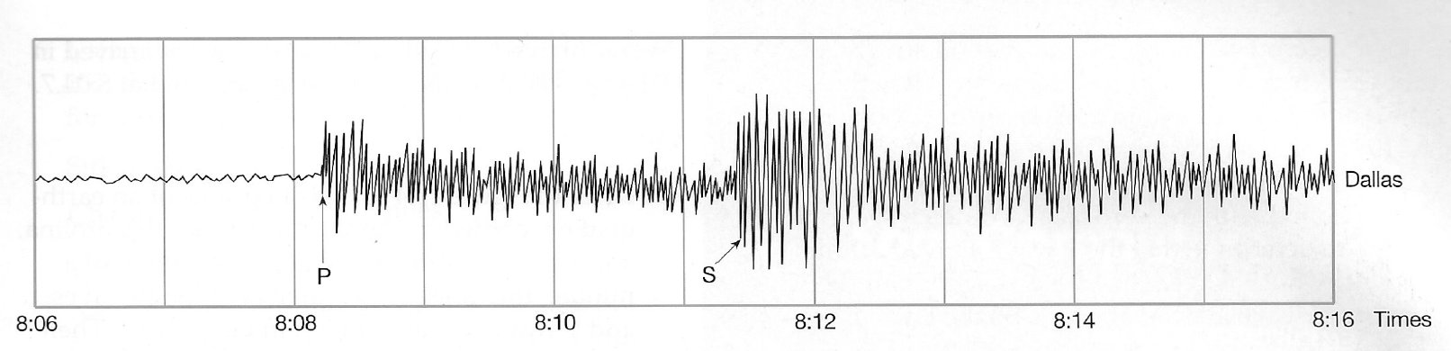

Seismograms can detect and record several types of body waves, which are waves that travel through Earth’s “body” (rather than along its surface) and radiate in all directions from the focus. Two of these body waves are used to locate earthquake epicenters:
- P-waves: “P” for primary, because they travel fastest and arrive at seismographs first. (They are compressional or “push-pull” waves, and will travel through both solids and liquids).
- S-waves: “S” for secondary, because they travel more slowly and arrive at seismographs after the P-waves. (They are perpendicular or “side-to-side” waves, and only travel through solid material).
Seismographs also detect surface waves, called L-waves or Love waves (named for A.E.H. Love, who discovered them). L-waves travel along Earth’s surface (a longer route) and thus are recorded after the S-waves and P-waves arrive at the seismograph.

Travel-Time Curves
Figure 2 shows travel-time curves, graphs that indicate how long it takes each type of seismic wave to travel a distance, measured on Earth’s surface. Note the curvature of the S and P lines, and the nearly straight line for the surface (L) waves. The difference between the S-wave arrival time and the P-wave arrival time is called S-minus-P. This time difference can be converted readily into distance of the seismograph from the earthquake focus using the travel-time curves.

For example, study Figure 1 above – a seismogram recorded in Dallas, Texas. Note the zigzags indicating the arrival of P-waves and the zigzags indicating the arrival of S-waves, labeled on the figure. The P-waves began to arrive at 8:08.2, and the S-waves began to arrive at 8:11.3 (3.1 minutes after the P-waves). In other words, the difference in arrival times between the S-waves and P-waves is 3.1 minutes.
Follow these steps to determine the distance from the seismograph to the focus of the earthquake (i.e., focus-to-seismograph distance) recorded at Dallas using S-minus-P and the travel-time curves (Figure 2).

Step 1: On Figure 2, lay a strip of blank paper along the time axis. Mark two dots on the edge of the paper corresponding to the 3.1-minute (S-minus-P) time interval (i.e., mark dots at 0 and 3.1).

Step 2: Keeping the edge of the paper parallel to the vertical lines, slide the paper up along the S and P curves until the two dots lie exactly on the S and P curves.

Step 3: A vertical line through the S and P curves at these points should intersect the horizontal axis at 1000 miles. This is the distance between the seismograph at Dallas and the earthquake focus (focus-to-seismograph distance). So, you know that the earthquake happened 1000 miles from Dallas, but you don’t know specifically where. To determine that, you need seismograms from three recording stations, as you will see shortly.

The seismogram recorded at Dallas is not long enough to show the time when L-waves arrived. However, you can find this information after Step 3 above. When you determine the vertical line through the S and P curves that intersects the horizontal axis at 1000 miles, simply project the same line to the L curve. The length of this line segment is 4 cm and can be measured with the vertical (time) axis of the travel-time graph to determine that the L wave arrived 3.1 minutes after the S wave. The Dallas seismogram shows that the S wave arrived at 8:11.4. So the L wave arrived 3.1 minutes later, at 8:14.5.
You can also use the travel-time curves to determine the time at which the earthquake in Figure 1 occurred. Project a horizontal line to the time axis of the graph from the point where the vertical line (from preceding paragraph) passes through the P-wave travel-time curve. This indicates that the earthquake occurred 3.5 minutes before the first P-wave arrived at Dallas. The first P-wave arrived in Dallas at 8:08.2, so the earthquake occurred at 8:04.7.

EXERCISE

A single earthquake produced the seismograms (attached) at three different locations (Alaska, North Carolina, and Hawaii). Times have been standardized to Charlotte, North Carolina, to simplify comparison. Use these seismograms and a seismic wave travel-time curve to locate the epicenter of the earthquake that produced the seismograms.

- Using the seismograms (attached), estimate to the nearest tenth of a minute the times that P-waves and S-waves first arrived at each seismic station (Sitka, Charlotte, and Honolulu). Record these times in the table provided in Lab #3.

- Subtract P from S to get the S-minus-P time interval. Record the time difference in the table provided in Lab #3.

- Using the S-minus-P time intervals determined in 1) and the travel-time curves (Figure 2, attached), determine the distance from the epicenter (in miles) for each seismic station. Record these distances in the table provided in Lab #3.

- Use the following geographic coordinates to locate and mark the three recording stations on the World map (attached). Plot these points as exactly as you can.

Sitka, AK: 57°N latitude, 135°W longitude
Charlotte, NC: 35°N latitude, 81°W longitude
Honolulu, HI: 21°N latitude, 158°W longitude

- Use a drafting compass to draw a circle around each recording station. Make the radius of each circle equal to the distance from epicenter determined for the station in step 3) above. Use the scale on the map to set this radius on your drafting compass. The circles you draw should intersect approximately at one point on the map. This point is the epicenter! (If the three circles do not quite intersect at a single point, then find a point that is equidistant from the three edges of the circles, and use this as the epicenter). Record the location of the earthquake epicenter in Lab #3.

- Using the example of the seismogram from Dallas (detailed in the Background for this exercise), come up with the origin time of the earthquake (the time the earthquake occurred). Use Sitka, AK as your starting point. Record the time the earthquake occurred in Lab #3.

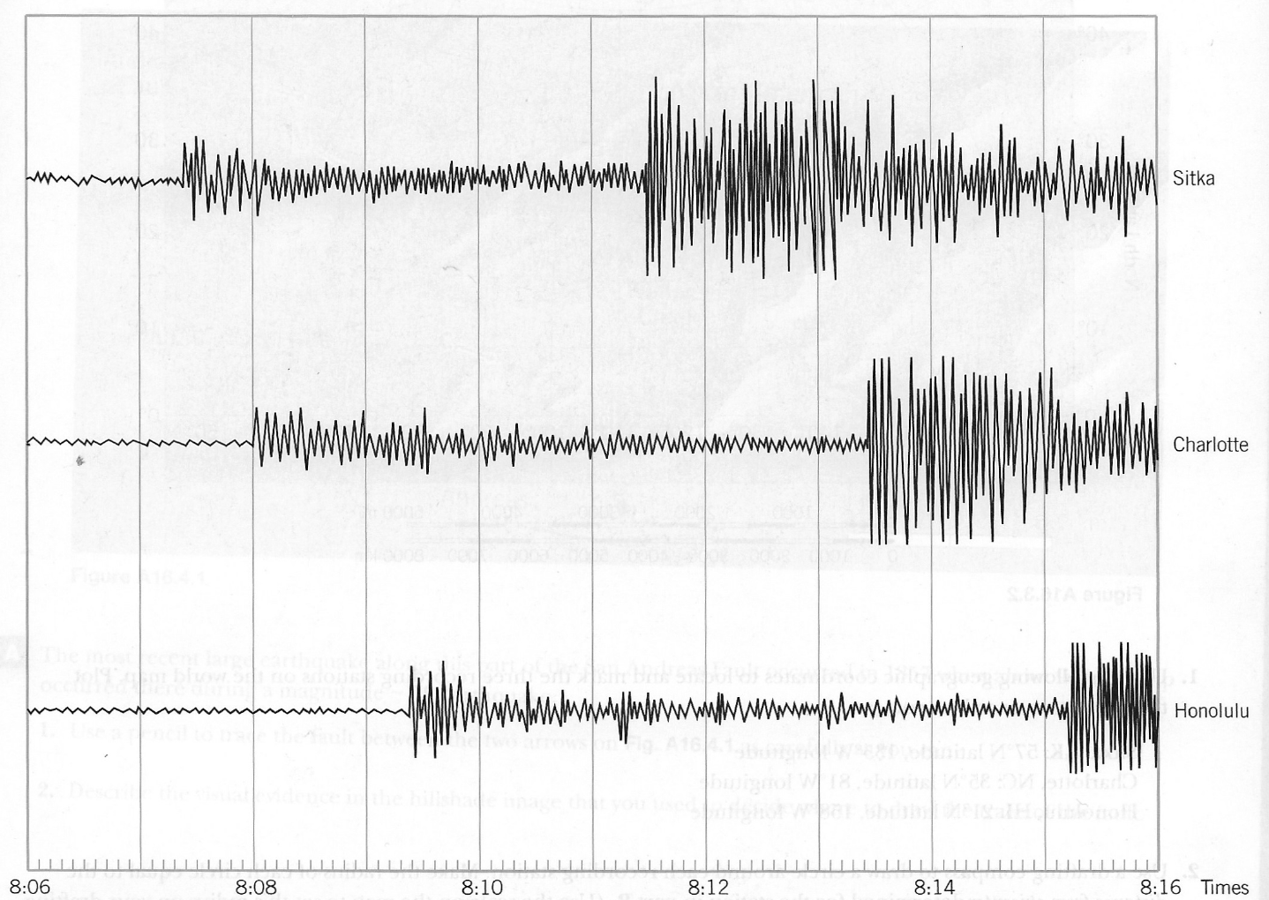

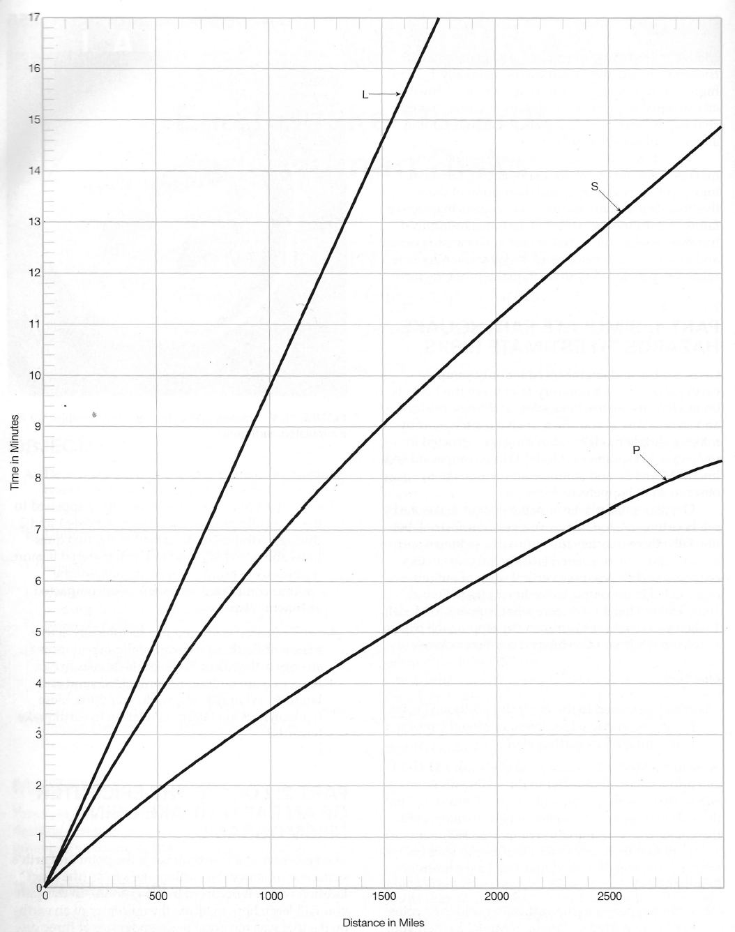

Figure 2: Travel-time curves

